SOME APPLICATION OF FIRST ORDER DIFFERENTIAL EQUATION

Introduction:

There are many applications of first order differential equations to real world problems,

the following linear and non-linear models as an application:

* **Cooling/ and warming law**
* **Population growth and decay**
* **Harvesting renewable natural resources**
* **Prey and predator**
* **A Falling object with air resistance**

**Question No. 1**

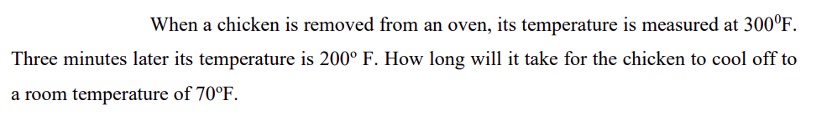

**Question No. 2**

